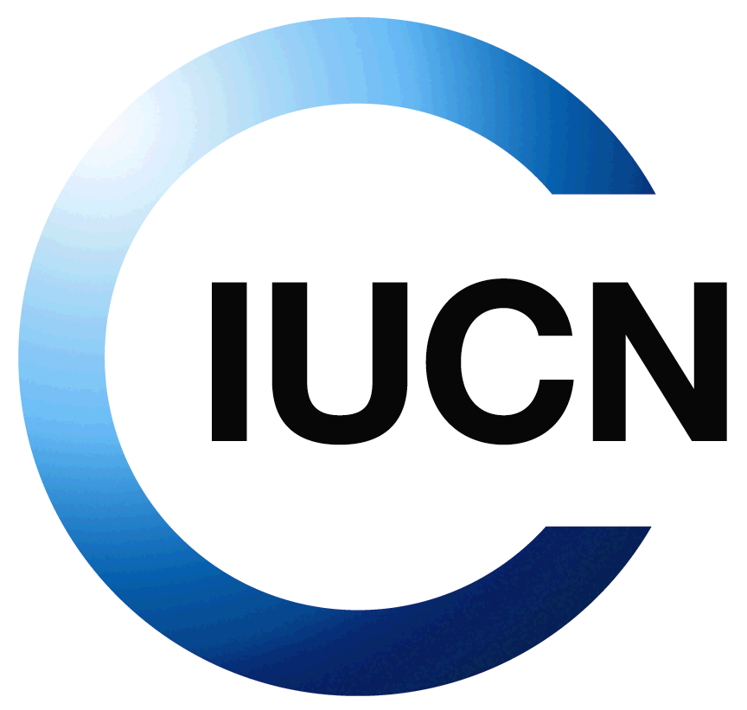
Protected Planet Pavilion

Template for event proposals
5 April 2012

NB: Please read carefully the Pavilion planning document before completing this template and familiarize yourself with the Pavilion’s slogan, objectives, daily themes and principles for events.

Please return the completed template to james.kemsey@iucn.org with subject title “Protected Planet Pavilion proposal” no later than 15th April 2012.

Component Programme (Region, Commission, Global Thematic Programme)
Lead person

Draft Title of Event
On which date would you like your event? | - 7th October  - 8th October  - 9th October  - 10th October  - 11th October
Preferred time slot  (if relevant) | - Happy Hour  - Lunch  - Forum am or pm  Additional information on this preference:
Partners (IUCN programmes/regions, commissions, members other external partners)

Objectives of your event
Format of event
Do you have resources to cover catering costs?

Special requirements or other information (e.g. specific equipment that might be required)

